For each question from 11 to 15, shade your answer (1, 2, 3 or 4) on the Optical  
Answer Sheet (OAS). (5 marks)

~ 41, Although Mary:was determined to cut down sugar in her diet, her plans were  
. by the box of. chocolates on her table..

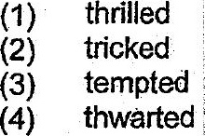

12. The robber who threatened the cashier with a knife was charged in court with ~ |  
iNegal :__ of adangerous weapon in public, ;

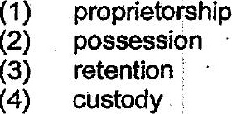

13. The children are feeling nervous at the competition because they are  
: the best swimming team in the country.

{1) going by  
  
(2) going over  
  
(3) going up against  
(4) going ahead with



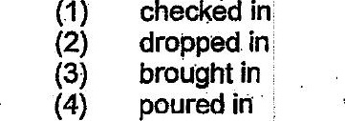

(1) marred |  
  
(2) maimed  
  
(3) distorted.  
  
(4) disarfayed